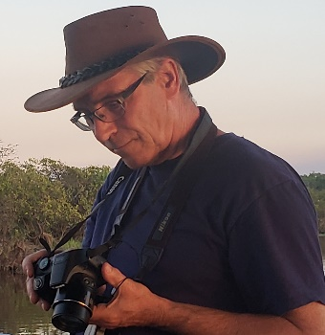

BIO:
Prof. Marinus L. Otte
Wet Ecosystem Research Group
Biological Sciences, Dept. 2715, North Dakota State University, PO Box 6050, Fargo, ND 58108-6050
Office 701-231-8708, Mobile 701-526-6971
marinus.otte@ndsu.edu, www.ndsu.edu/werg

Education/Professional
- MSc (1986) and PhD (1991), Amsterdam, Netherlands
- 1991-1992 Research Assistant Professor, University of South Carolina
- 1992-2006, University College Dublin, Ireland, Full Professor 2002
- 2006-present, NDSU, Fargo, ND, USA
- Trained 30 MSc and 30 PhD students in The Netherlands, Ireland, USA, UK, Sweden, Italy, India, China
- Invited/Keynote speaker, 80 times, including Regional/National: EPA, Duluth, MN, September 2007; Fifth Annual Mayor’s Big Sioux River Water Summit, Watertown, SD, 2017; and International: Northeast Institute of Geography and Agroecology, Chinese Academy of Sciences (CAS), Changchun, China, 2016; Joint meeting, Society of Wetland Scientists and the Korean Wetland Society, S. Korea, 2019
- Published 100 research articles in peer-reviewed international scientific journals and co-authored 200 conference presentations
- Global scientist – projects in Netherlands, Ireland, Kyrgyzstan, USA, China, Taiwan, and Montenegro.

Wetland Community Service / Collaborators / Funding /Professional
- Member, ND Water Quality Monitoring Council since 2009; ND State K-12 Science Standards Committee, Department of Public Instruction, since 2013
- Professional memberships: Society of Wetland Scientists, Phytotechnology Society, Sigma Xi
- Editor-in-Chief of the international scientific journal ‘WETLANDS’ since 2012
- Demonstrated research success: received funding from USEPA, North Dakota Department of Health/Environmental Quality, CAS, NIH, USDA, Irish EPA, EU COST, Irish Science Foundation, INTAS
- Collaborated with colleagues in Engineering and Agriculture at NDSU, UMN, Morris, MN DNR and internationally: recently with NTNU, Taiwan (2012-current), and CAS, China (2014-currebt), and Autonomous University of Querétaro, Mexico (September 2021)
- Expert witness for court cases in Ireland (High Court) and USA (MN Office of Administrative Hearings)

Research Interests and Projects
- Wetland ecology, biogeochemistry, restoration, pollution, and ecotoxicology.
- Past work focused on pollution of water and sediments in wetlands, nanoparticles in the environment, uptake in wetland plants and animals, vegetation surveys, and on how wetlands can be used for improvement of water quality, including constructed wetlands, also for industrial and mine wastewater.
- Current projects include:
- Success of restoration of wetlands in North Dakota (USEPA,2019-2021). Intact and restored Prairie Pothole wetlands are compared regarding biodiversity, soil element composition, and carbon sequestration.
- Success of restoration of wetlands in China (CAS, 2016-2020). Riparian wetlands along large rivers are compared for soil composition, and animal and plant diversity.
- Development of reference wetlands in China for restoration and protection of clean water. The USA has reference wetlands, those relatively unimpacted by humans. That is different in China, where wetlands have been altered for thousands of years. The aim of this project (CAS, 2020-2021) is to determine which wetlands across the nation can be used as quality examples for measuring restoration success.
- Fulbright Specialist 2021-2025, see https://fulbrightspecialist.worldlearning.org/. Querétaro, Mexico, September 2021, development of nature-based sustainable approaches to improvement of water quality.

